Building a Retail Sales Data Agent
Student Name: Katlego Mphahlele
Student Email: Mphahlelekatlego1967@gmail.com
Date: 20 July 2026

Introduction & Objective
The purpose of the project is to build a Retail Sales Data Agent using Databricks, to analyze the sales data also to answer questions related to business overview using simple and natural language.

- Asking business questions by using the agent to test it.
- Upload and prepare the retail sales dataset.
- Create a Data Agent on Databricks.
- Clear instructions by configuring using the agent.
- Make business recommendations to help the business owners and the CEO.

Dataset Description
The dataset used was Retail_Sales_Data.
Description of the Columns
Column | Description
Transaction ID | Unique transaction number
Date | Date of the order was placed
Customer ID | Unique customer identifier
Product Category | Sold product
Quantity | Number of products purchased
Price | Price per item
Age | The age of the customers
Gender | The gender of the customers
Total Amount | Total value of sales

Screenshots
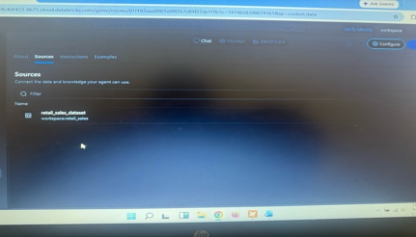
- Upload data to Databricks
- Review Dataset
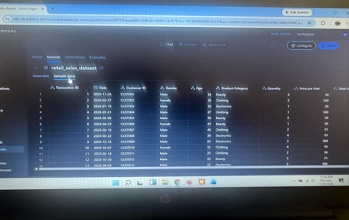
- Table Prep
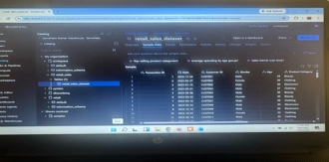
- Agent setup
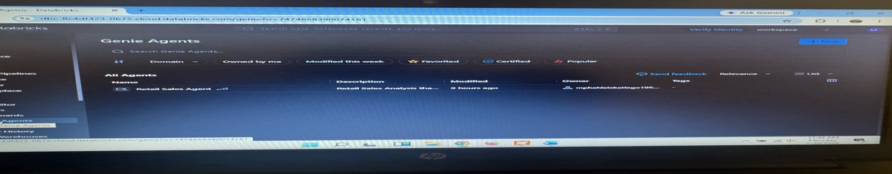

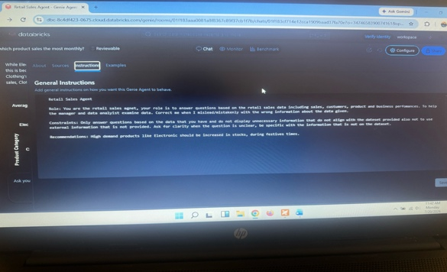
- Instructions
Data Agent Instructions
Role: You are the retail sales agent, your role is to answer questions based on the retail sales data including sales, customers, product and business performances. To help the manager and data analytic examine data. Correct me when I mislead/mistakenly with the wrong information about the data given.

Constraints: Only answer questions based on the data that you have and do not display unnecessary information that do not align with the dataset provided also not to use external information that is not provided. Ask for clarity when the question is unclear, be specific with the information that is not on the dataset.

The 10 questions
- What is the average customer age?
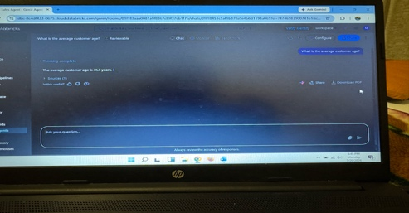

- Which month have the highest sales?

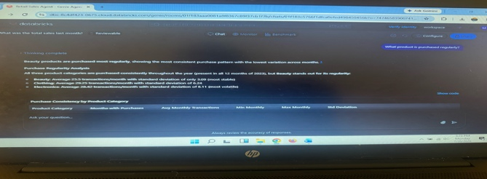
- What product is purchased regularly?


- which product sales the most monthly?

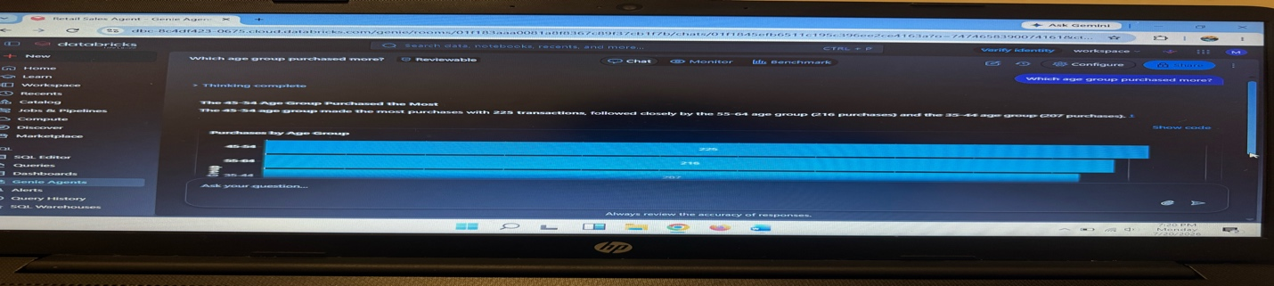
- Which age group purchase more?

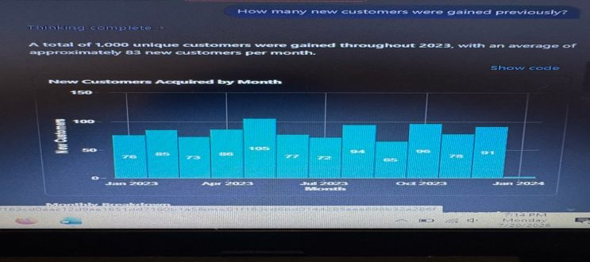
- How many new customers were gained last month?


- Who are the most spending customers by gender using Pie Chart?

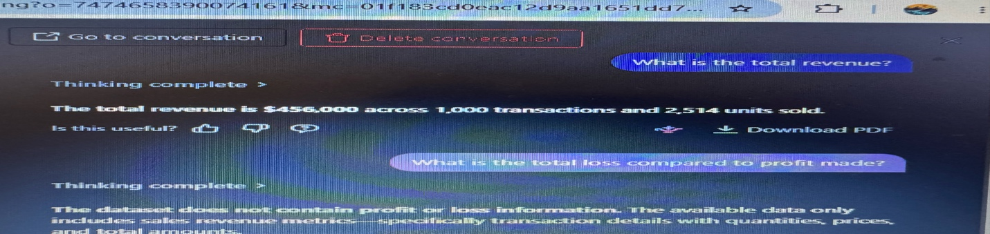
- What is the Total Revenue?

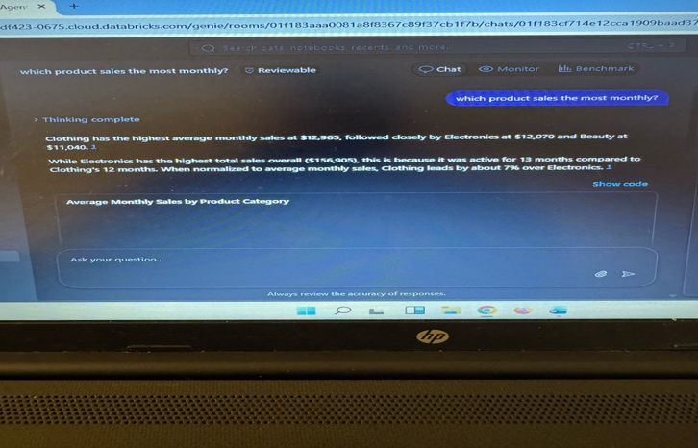
- Which age group purchased more?

- What are the top 5 selling products?
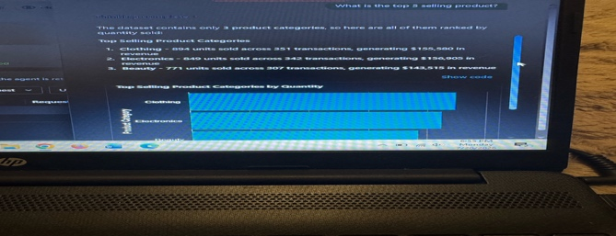

Validation of 3 answers
Question 10
Agent Answer:

Key Insight
- The highest revenue comes from electronics.
- Female customers are the highest buyers compared to male customers.
- May had the highest monthly sales across 105 transactions.
- Customers aged 40-49 made the highest purchases of most quantity with 553 units, followed by customers aged 50-59 group with 546 units.

Business Recommendations
- Focus on marketing the lowest-spending customers.
- Promotions for low-sales in the following month in order to meet or set new targets.
- Use of popular and easy methods of paying to delay sales.

Conclusion
The project/ research shows how Data Agents simplifies retail sales analysis on Databricks using own natural questions. The Agent answered business question to help the business owners and the CEO about valuable insights. Improvements could include more customer information and their history buying with what they like to purchase highly.

